EXPERIMENT NO. 3: ONLINE BUS TICKET BOOKING SYSTEM
AIM:
To construct an interactive online bus ticket booking web portal supporting route searches, coach category selection (Volvo, Sleeper, Luxury), dynamic interactive seat layout selection, booking cancellations, and administrator schedule management.
PSEUDOCODE (IN 6 SIMPLE POINTS):
Step 1: Initialize bus route inventory with source, destination, departure time, bus categories, and seat layouts.
Step 2: Allow users to enter travel source, destination, and journey date to query available buses.
Step 3: Render an interactive 2D seat matrix visually displaying available, reserved, and selected seats.
Step 4: Enable passengers to click and choose seats, updating total ticket fare in real time based on bus tier.
Step 5: Confirm booking with passenger name and contact, generating a printable e-ticket with PNR and seat numbers.
Step 6: Equip admin with controls to add new bus categories, update available seating capacities, and handle ticket cancellations.
SOURCE CODE:
<!DOCTYPE html>
<html lang="en">
<head>
<meta charset="UTF-8">
<title>ExpressBus Ticket Booking</title>
<style>
body { font-family: Arial, sans-serif; margin: 0; background: #f1f5f9; }
header { background: #dc2626; color: white; padding: 20px; text-align: center; }
.container { max-width: 900px; margin: 20px auto; background: white; padding: 25px; border-radius: 8px; box-shadow: 0 2px 8px rgba(0,0,0,0.1); }
.form-row { display: flex; gap: 15px; margin-bottom: 20px; }
select, input, button { padding: 10px; border: 1px solid #ccc; border-radius: 4px; font-size: 14px; flex: 1; }
button { background: #dc2626; color: white; border: none; font-weight: bold; cursor: pointer; }
button:hover { background: #b91c1c; }
.seat-grid { display: grid; grid-template-columns: repeat(4, 50px); gap: 12px; margin: 20px 0; justify-content: center; background: #fafafa; padding: 20px; border-radius: 8px; }
.seat { width: 50px; height: 50px; background: #e2e8f0; border: 1px solid #cbd5e1; border-radius: 6px; display: flex; align-items: center; justify-content: center; cursor: pointer; font-weight: bold; }
.seat.selected { background: #16a34a; color: white; }
.seat.occupied { background: #94a3b8; color: white; cursor: not-allowed; }
.ticket-card { border: 2px dashed #dc2626; padding: 15px; background: #fef2f2; border-radius: 8px; margin-top: 20px; }
</style>
</head>
<body>
<header>
<h2>ExpressBus Reservation System</h2>
</header>
<div class="container">
<div class="form-row">
<select id="route">
<option value="Chennai to Bangalore">Chennai -> Bangalore (Volvo AC - Rs. 850)</option>
<option value="Bangalore to Hyderabad">Bangalore -> Hyderabad (Sleeper Coach - Rs. 1,100)</option>
<option value="Chennai to Madurai">Chennai -> Madurai (Semi-Sleeper - Rs. 650)</option>
</select>
<input type="date" id="travelDate" required>
<button onclick="loadBusLayout()">Search Bus</button>
</div>
<div id="seatSection" style="display: none;">
<h3>Select Your Preferred Seats (Click to select/deselect)</h3>
<div style="display: flex; gap: 15px; justify-content: center; font-size: 13px;">
<span><span style="display:inline-block; width:15px; height:15px; background:#e2e8f0;"></span> Available</span>
<span><span style="display:inline-block; width:15px; height:15px; background:#16a34a;"></span> Selected</span>
<span><span style="display:inline-block; width:15px; height:15px; background:#94a3b8;"></span> Occupied</span>
</div>
<div class="seat-grid" id="seatContainer"></div>
<div style="text-align: center;">
<p>Selected Seats: <b id="selectedSeatList">None</b> | Total Fare: <b>Rs. <span id="totalFare">0</span></b></p>
<input type="text" id="passengerName" placeholder="Primary Passenger Name" style="max-width: 300px; margin-bottom: 10px;"><br>
<button onclick="confirmBusTicket()" style="max-width: 250px;">Confirm & Pay</button>
</div>
</div>
<div id="ticketReceipt"></div>
</div>
<script>
let selectedSeats = [];
let seatPrice = 850;
function loadBusLayout() {
let route = document.getElementById('route').value;
seatPrice = route.includes('1,100') ? 1100 : (route.includes('650') ? 650 : 850);
let container = document.getElementById('seatContainer');
container.innerHTML = '';
selectedSeats = [];
updateFare();
document.getElementById('seatSection').style.display = 'block';
for(let i = 1; i <= 16; i++) {
let seat = document.createElement('div');
seat.className = 'seat';
seat.innerText = i;
if(i === 3 || i === 7 || i === 12) {
seat.classList.add('occupied');
} else {
seat.onclick = function() { toggleSeat(seat, i); };
}
container.appendChild(seat);
}
}
function toggleSeat(elem, num) {
if(elem.classList.contains('selected')) {
elem.classList.remove('selected');
selectedSeats = selectedSeats.filter(s => s !== num);
} else {
elem.classList.add('selected');
selectedSeats.push(num);
}
updateFare();
}
function updateFare() {
document.getElementById('selectedSeatList').innerText = selectedSeats.length ? selectedSeats.join(', ') : 'None';
document.getElementById('totalFare').innerText = (selectedSeats.length * seatPrice).toLocaleString();
}
function confirmBusTicket() {
let name = document.getElementById('passengerName').value.trim();
if(!name) return alert('Please enter Passenger Name');
if(!selectedSeats.length) return alert('Please select at least one seat');
let pnr = 'BUS' + Math.floor(100000 + Math.random()*900000);
let route = document.getElementById('route').value;
let date = document.getElementById('travelDate').value;
document.getElementById('ticketReceipt').innerHTML = `
<div class="ticket-card">
<h3 style="margin-top:0; color:#dc2626;">Bus E-Ticket Confirmation</h3>
<p><b>PNR No:</b> ${pnr} | <b>Passenger:</b> ${name}</p>
<p><b>Route:</b> ${route} | <b>Journey Date:</b> ${date}</p>
<p><b>Seats Booked:</b> ${selectedSeats.join(', ')} | <b>Total Paid:</b> Rs. ${(selectedSeats.length * seatPrice).toLocaleString()}</p>
<small>Show this e-ticket along with valid Govt ID proof during boarding.</small>
</div>`;
}
</script>
</body>
</html>
Output:
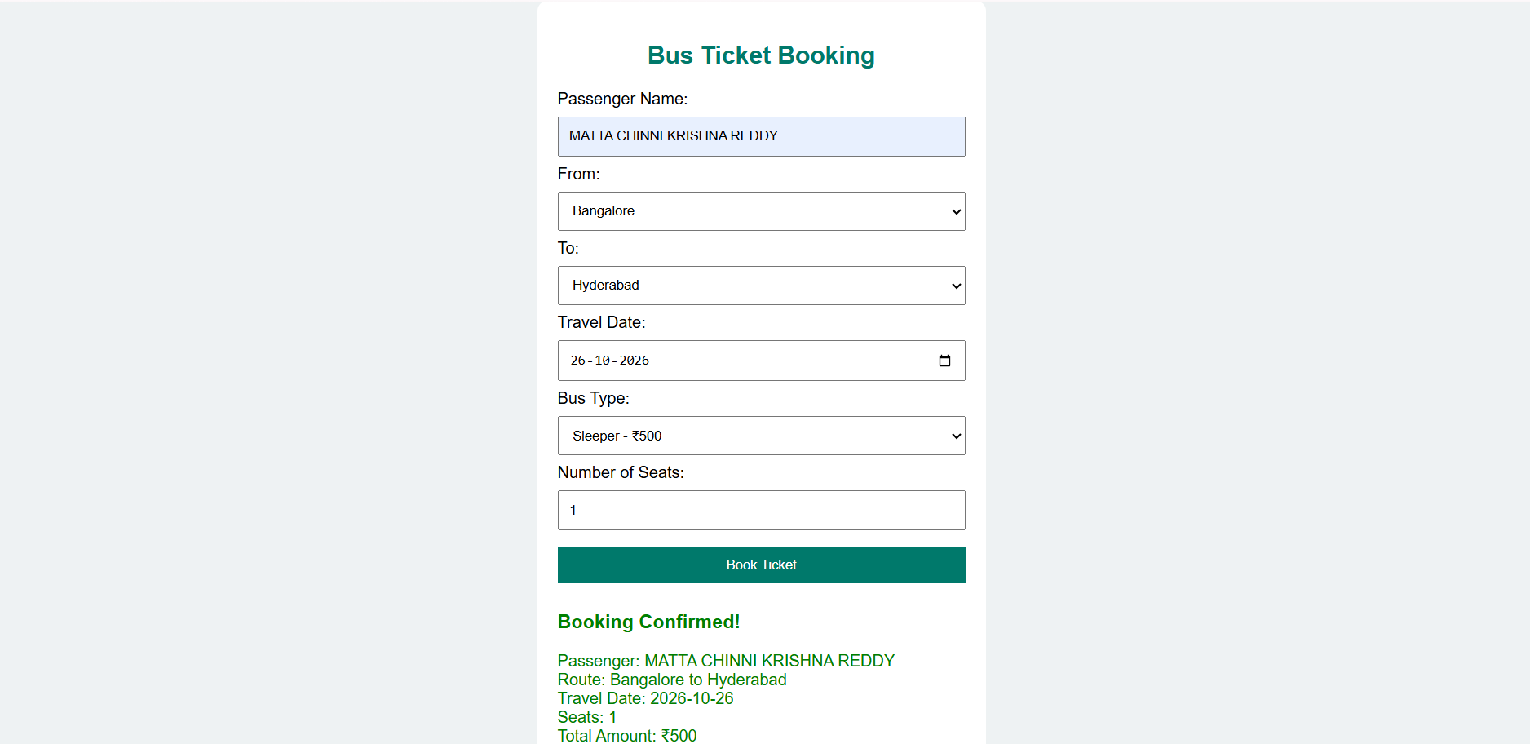
RESULT:
Thus, the online bus ticket booking web application was successfully created and verified with dynamic route selection, graphical seat layout, real-time ticket fare calculation, and e-ticket generation.

